Lab Manual for Computer Communication and Networking
Lab No. 1
INTRODUCTION TO PACKET TRACER

BAHRIA UNIVERSITY KARACHI CAMPUS
Department of Software Engineering

COMPUTER COMMUNICATION & NETWORKING

LAB EXPERIMENT # 1

Simple Connections and Configurations on Packet Tracer Software

OBJECTIVE:

- To learn the working and basic operation of Cisco’s Packet Tracer Software.

WHAT IS PACKET TRACER?
Packet Tracer is a protocol simulator developed by Dennis Frezzo and his team at Cisco Systems. Packet Tracer (PT) is a powerful and dynamic tool that displays the various protocols used in networking, in either Real Time or Simulation mode. This includes layer 2 protocols such as Ethernet and PPP, layer 3 protocols such as IP, ICMP, and ARP, and layer 4 protocols such as TCP and UDP. Routing protocols can also be traced.

Purpose:
The purpose of this lab is to become familiar with the Packet Tracer interface. Learn how to use existing topologies and build your own.

Requisite knowledge:
This lab assumes some understanding of basic computer working and basic knowledge of a network.
Version: This lab is based on Packet Tracer 7.3.0.

Introduction to the Packet Tracer Interface using a Hub Topology

Step 1: Start Packet Tracer and Entering Realtime Mode

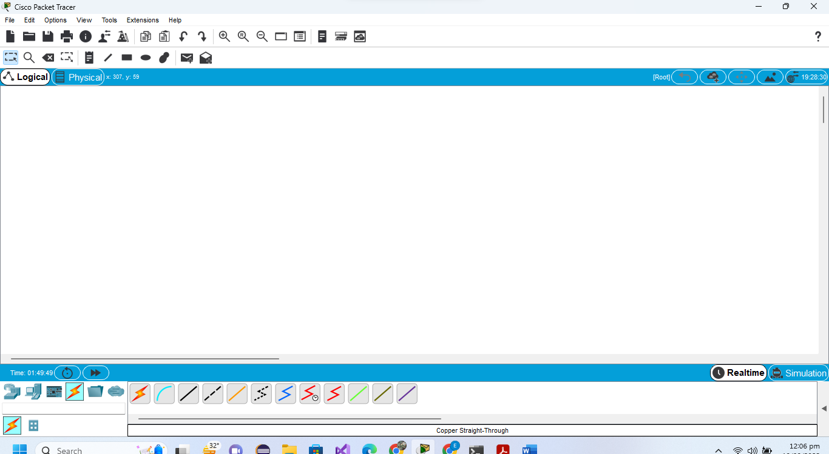

Step 2: Choosing Devices and Connections
We will begin building our network topology by selecting devices and the media in which to connect them.

Several types of devices and network connections can be used. For this lab we will keep it simple by using End Devices, Switches, Hubs, and Connections.

Single click on each group of devices and connections to display the various choices.

Step 3: Building the Topology – Adding Hosts

Single click on the End Devices.
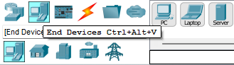

Single Click on PC host

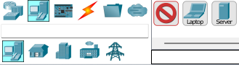

Move the cursor into topology area. You will notice it turns into a plus “+” sign.
Single click in the topology area and it copies the device.

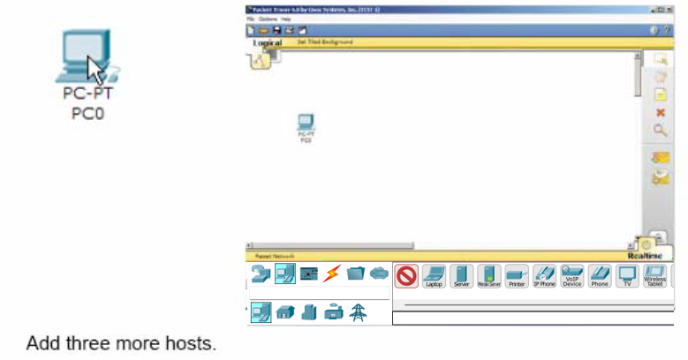

Step 4: Building the Topology – Connecting the Hosts to Hubs and Switches

Adding a Hub
Select a hub, by clicking once on Hubs and once on a Generic hub.

Perform the following steps to connect PC0 to Hub0:
1. Click once on PC0
2. Choose Fast Ethernet
3. Drag the cursor to Hub0
4. Click once on Hub0 and choose Port 0
5. Notice the green link lights on both the PC0 Ethernet NIC and the Hub0 Port 0 showing that the link is active.

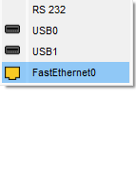
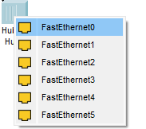

Add the switch by moving the plus sign “+” below PC2 and PC3 and click once.

Connect PC2 to Switch0 by first choosing Connections.

Click once on the Copper Straight-through cable.

Perform the following steps to connect PC2 to Switch0:
1. Click once on PC2
2. Choose FastEthernet
3. Drag the cursor to Switch0
4. Click once on Switch0 and choose FastEthernet0/1
5. Notice the green link lights on PC2 Ethernet NIC and amber light Switch0 FastEthernet0/1 port. The switch port is temporarily not forwarding frames, while it goes through the stages for the Spanning Tree Protocol (STP) process.
6. After about 30 seconds the amber light will change to green indicating that the port has entered the forwarding stage. Frames can now forward out the switch port.

Step 5: Configuring IP Addresses and Subnet Masks on the Hosts

Before we can communicate between the hosts we need to configure IP Addresses and Subnet Masks on the devices.

Click once on PC0.
Choose the Config tab:
It is here that you can change the name of PC0. It is also here where you would enter a Gateway IP Address, also known as the default gateway. We will discuss this later, but this would be the IP address of the local router. If you want, you can enter the IP Address 172.16.1.1, although it will not be used in this lab.
Click on FastEthernet:
Although we have not yet discussed IP Addresses, add the IP Address to 172.16.1.10. Click once in the Subnet Mask field to enter the default Subnet Mask. You can leave this at 255.255.0.0. We will discuss this later.

Also, notice this is where you can change the Bandwidth (speed) and Duplex of the Ethernet NIC (Network Interface Card). The default is Auto (autonegotiation), which means the NIC will negotiate with the hub or switch. The bandwidth and/or duplex can be manually set by removing the check from the Auto box and choosing the specific option.

Bandwidth - Auto
If the host is connected to a hub or switch port which can do 100 Mbps, then the Ethernet NIC on the host will choose 100 Mbps (Fast Ethernet). Otherwise, if the hub or switch port can only do 10 Mbps, then the Ethernet NIC on the host will choose 10 Mbps (Ethernet).

Duplex - Auto

Hub: If the host is connected to a hub, then the Ethernet NIC on the host will choose Half Duplex.

Switch: If the host is connected to a switch, and the switch port is configured as Full Duplex (or Auto-negotiation), then the Ethernet NIC on the host will choose Full Duplex. If the switch port is configured as Half Duplex, then the Ethernet NIC on the host will choose Half Duplex. (Full Duplex is a much more efficient option.)
The information is automatically saved when entered.

Repeat these steps for the other hosts. Use the information below for IP Addresses and Subnet Masks.
Host | IP Address | Subnet Mask
PC0 | 172.16.1.10 | 255.255.0.0
PC1 | 172.16.1.11 | 255.255.0.0
PC2 | 172.16.1.12 | 255.255.0.0
PC3 | 172.16.1.13 | 255.255.0.0

Verify the information
To verify the information that you entered, move the Select tool (arrow) over each host.

Deleting a Device or Link
To delete a device or link, choose the Delete tool and click on the item you wish to delete.

Step 6: Connecting Hub0 to Switch0
To connect like-devices, like a Hub and a Switch, we will use a Cross-over cable. Click once the Cross-over Cable from the Connections options.

Move the Connections cursor to Switch0.

Click once on Switch0 and choose FastEthernet0/4 (actual port does not matter).

The link light for switch port FastEthernet0/4 will begin as amber and eventually change to green as the Spanning Tree Protocol transitions the port to forwarding.

Lab Task:
Implement the following network on packet tracer.

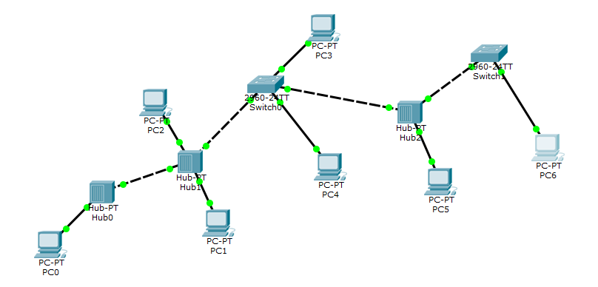

Ping,
- PC0 from PC5,
- PC6 from PC2,
- PC3 from PC1,
Also, display the above results in the simulation mode of packet tracer. Attach snapshots of the pinging results and the network created.

Complete the following table:

End Device | IP Used
PC0
PC1
PC2
PC3
PC4
PC5
PC6

TIME BOXING:

Activity Name | Activity Time | Total Time
Instruments Allocation + Setting up Lab | 10 mints | 10 mints
Walk through Theory & Tasks (Lecture) | 60 mints | 60 mints
Implementation & Practice time | 90 mints | 80 mints
Evaluation Time | 20 mints | 20 mints
 | Total Duration | 180 mints

Teacher Signature: ________________________

Student Registration No: ________________________

